DDS Registry

DDS Registry Metadata Datamodel

Contents
1 Introduction 4
1.1 Purpose 4
1.2 Reading guide 4
1.3 Document history 4
1.4 Definitions and references 4
2 Metadata data model 6
2.1 The IHE XDS profile 6
2.1.1 Deprecation of documents in registry 7
3 Fields of the data model 8
3.1 Description of the model’s fields 9
3.2 Fields fixed by the affinity domain 9
3.2.1 classCode 9
3.2.2 comments 10
3.2.3 confidentialityCode 10
3.2.4 eventCodeList 10
3.2.5 formatCode 10
3.2.6 healthcareFacilityTypeCode 11
3.2.7 practiceSettingCode 11
3.2.8 typeCode 11
3.3 Fields fixed by standards 11
3.3.1 Author 11
3.3.2 AvailabilityStatus 13
3.3.3 creationTime 13
3.3.4 entryUUID 13
3.3.5 hash 13
3.3.6 homeCommunityId 13
3.3.7 languageCode 14
3.3.8 legalAuthenticator 14
3.3.9 mimeType 14
3.3.10 patientId 14
3.3.11 repositoryUniqueId / sourceId 14
3.3.12 serviceStartTime 14
3.3.13 serviceStopTime 15
3.3.14 size 15
3.3.15 sourcePatientId 15
3.3.16 sourcePatientInfo 15
3.3.17 title 15
3.3.18 uniqueId 16
3.3.19 URI 16

Introduction

Purpose
The purpose of this document is to document the data model for metadata for National Patient Index.
The document contains an overview over which elements in the source system’s data model, that are included in the index as (virtual) documents, and how the source system’s data maps to the common document metadata structure.

Reading guide
The document is primarily directed towards system integrators for user systems (users of data in DDS) or source systems (suppliers of data for DDS).
The metadata model describes both general and source-specific details for the affinity domain. Thus, the latter must be updated when new sources join or pre-existing subscribers change.
In its current form, the document only contains descriptions of the parts of the model that can be determined with no joining by sources completed.

Document history
Version | Date | Responsible | Description
0.1 | 1.3.2012 | Systematic | Initial version
1.0 | 29.6.2012 | Systematic | Removed the list of source system  Extended with preliminary description for parts of the model
1.1 | 11.12.2012 | Systematic | Extended with on-demand sources and additional information on metadata fixed by the affinity domain
1.1a | 19.04.2013 | NSI | THSC comments
1.2 | 19.06.2013 | Systematic | Linguistic corrections, content is partially unsettled
1.3 | 28.11.2014 | Systematic | National Patient Index (NPI) replaced by Document Sharing Service (DDS)

Definitions and references
The purpose of this section is to provide an overview of the definitions and documents used in this document.
Definition | Description
DDS | Dokument Sharing Service
NSI | National eHealth Authority
NSP | The national service platform (within NSI)

Alias | Description
IHE1 | IHE Current Technical Framework – Revision 8.0, vol1 (Integration Profiles)  http://www.ihe.net/Technical_Framework/upload/IHE_ITI_TF_Rev8-0_Vol1_FT_2011-08-19.pdf
IHE2 | IHE Current Technical Framework – Revision 8.0, Vol. 2a: Transactions (ITI1-ITI28) http://www.ihe.net/Technical_Framework/upload/IHE_ITI_TF_Rev8-0_Vol2a_FT_2011-08-19.pdf
IHE3 | IHE Current Technical Framework – Revision 8.0, Vol. 2b: Transactions (ITI29-ITI64)  http://www.ihe.net/Technical_Framework/upload/IHE_ITI_TF_Rev8-0_Vol2b_FT_2011-08-19.pdf
IHE4 | IHE Current Technical Framework – Revision 8.0, Vol. 2x: http://www.ihe.net/Technical_Framework/upload/IHE_ITI_TF_Rev8-0_Vol2x_FT_2011-08-19.pdf
IHE5 | IHE Current Technical Framework – Revision 8.0, Vol. 3: (Transaction specifications) http://www.ihe.net/Technical_Framework/upload/IHE_ITI_TF_Rev8-0_Vol3_FT_2011-08-19.pdf
IHE6 | IHE Current Technical Framework Supplement On-Demand Documents http://www.ihe.net/Technical_Framework/upload/IHE_ITI_Suppl_On_Demand_Documents_Rev1-1_TI_2010-08-10.pdf
Metadata | Part of [IHE5]; specifically [IHE5] section 4.1.7
SUP | E-journalstandard - Bilag 1: Elementstruktur version 2.2 af 28/5-2010: http://www.medcom.dk/dwn3938

Metadata data model
The data model for metadata in DDS Registry obeys the data model for Document Definition Metadata in the IHE XDS profile.

The IHE XDS profile
Document sources are either static or on-demand sources.
Static sources register and store their documents in a repository, which can register information about the document in a registry.
On-demand sources create the documents only after they are requested, so they alone register the existence of the document in a registry.
Users can search the register and obtain information about the requested documents, while the actual document must be extracted from the repository and on-demand source, respectively.
The illustrations below illustrate the interaction between the profile components:
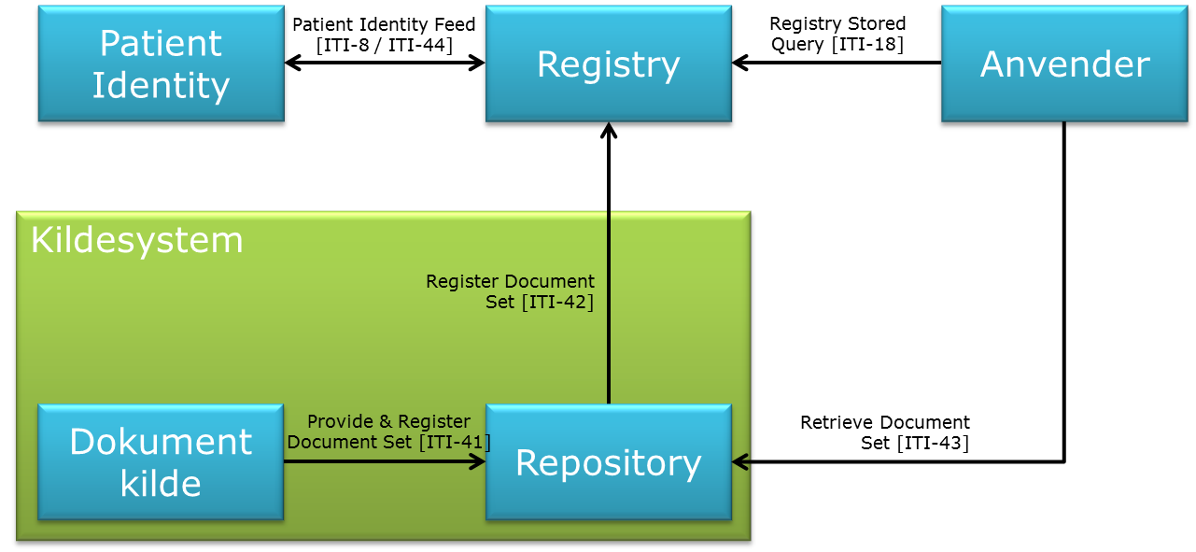
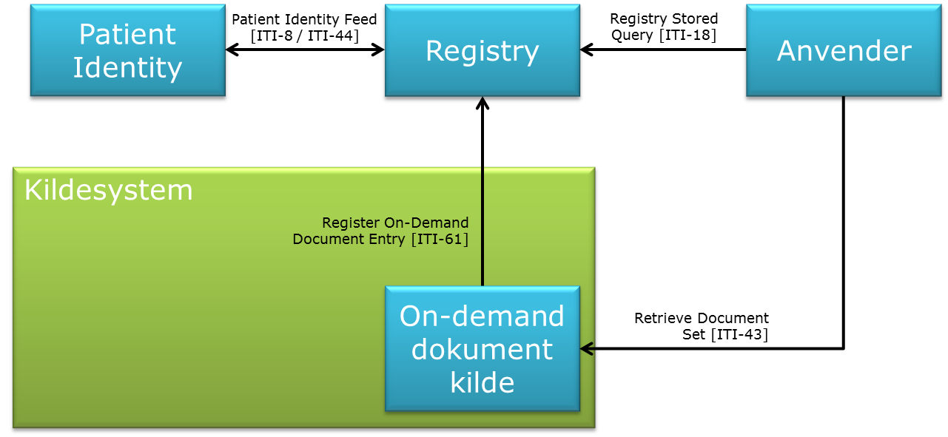
IHE XDS specify what information about documents – metadata – that is used to describe documents in the register. These are described in [Metadata].

Deprecation of documents in registry
On deprecation of a document (entry) in a registry, the exact same document metadata as for registration must be used. The only exception is availabilityStatus, which is set to Deprecated instead of Approved.

Fields of the data model
The model’s fields are contained in the table below. The fields are described in detail in the following section.
Attribute | Sub-attribute | Description | Required | Cardinality
classCode |  | General document type | Yes | Exactly 1
 | classCode
 | classCodeDisplayName
typeCode |  | Detailed document type | Yes | Exactly 1
 | typeCode
 | typeCodeDisplayName
eventCodeList |  | Clinical events in the document | No | Any
 | eventCodeList
 | eventCodeDisplayNameList
serviceStartTime |  | Start time for the clinical events in the document | Yes, if known | Exactly 1
serviceStopTime |  | End time for the clinical events in the document | Yes, if known | Exactly 1
title |  | Document name | No | At most 1
comments |  | Comments to the document | No | At most 1
confidentialityCode |  | Level of confidentiality for the document | Yes | At least1
 | confidentialityCode
 | confidentialityCodeDisplayName
author |  | Identification of organization and author of the document | Yes | Exactly 1
 | authorInstitution |  | No | At most 1
 | authorPerson |  | Yes | Exactly 1
 | authorRole |  | No | At most 1
 | authorSpecialty |  | No | At most 1
legalAuthenticator |  | The legal approver of the document | No | At most 1
healthcareFacilityTypeCode |  | Type of medical organization | Yes | Exactly 1
 | healthcareFacilityTypeCode
 | healthcareFacilityTypeCodeDisplayName
practiceSettingCode |  | The clinical area of specialization for the organization which wrote the document | Yes | Exactly 1
 | practiceSettingCode
 | practiceSettingCode DisplayName
repositoryUniqueId |  | Unique identification of the source system | Yes | Exactly 1
URI |  | Online reference to the document | No | At most 1
patientId |  | The patient’s social security number | Yes | Exactly 1
sourcePatientId |  | The patient’s ID in the source system, typically social security number | Yes | Exactly 1
sourcePatientInfo |  | The source system’s description of the citizen. Not used | No | At most 1
 | sourcePatientId
 | patientName
 | patientGender
 | patientDateOfBirth
 | patientAddress
availabilityStatus |  | Available in underlying repository [Approved, Deprecated] | Yes | Exactly 1
creationTime |  | Time of which the document was created | Yes | Exactly 1
entryUUID |  | Unique identifier of the document in the index | Yes | Exactly 1
uniqueId |  | Unique identification of the document | Yes | Exactly 1
formatCode |  | Unique entry for the document’s format | Yes | Exactly 1
 | formatCode
 | formatCodeDisplayName
hash |  | SHA-1 hash key for the document | Yes | Exactly 1
homeCommunityId |  | Identification of the domain | No | At most 1
languageCode |  | Character set used in the document | Yes | Exactly 1
mimeType |  | MIME type for the document | Yes | Exactly 1
size |  | Size of the document | No | At most 1

Description of the model’s fields
In the following, the details of each field is described in brief; how it is formatted, its possible sample space and an example.
Moreover, refer to [Metadata].
For selected fields, examples are provided. These show how a value is provided for the field in either ITI-42, ITI-61 or ITI-18.

Fields fixed by the affinity domain

classCode
The general type of document. The possible values must be selected from a fixed list of between 10 to 100 general types. The list is established by the definition of the affinity domain or in connection to the joining of sources. classCode can be expressed using a OID.
Combined attribute with two sub-attributes: a code and a textual description respectively.
Example of Region Sjællands’ OID for classCodes: 1.2.208.177.1.0.1.9
At present, sample space contains 9 pcs.:
Code | Display Name | Description
11528-7 | Radiology Report | Used for XDS-SD documents
18748-4 | Diagnostic Imaging Report | Used for CDA-I documents
11488-4 | Consultation Note | Used for CDA-request (Zealand only)
55113-5 | Key images | Used for Dicom Kos objects
52040-3 | non-DICOM attachment | Used for Medimaker multimedia objects.
12347-9 | Examination Cancelled | Used for documents which signal document deletion
12447-9 | Patient Merge | Used for CDA to signal that patient id has been merged with other id
12547-9 | Patient Mixup | Used for CDA to signal that previous CDAs it replaces are registered to wrong patient
12647-9 | Duplicate information | Used for CDA to signal that a document is a copy of another document

classCode

classCodeDisplayName

comments
Free text comment for the document.
Format and sample space: Free text
Examples:
<rim:Description>
<rim:LocalizedString value="Annual check-up"/>
</rim:Description>

confidentialityCode
One or more codes that indicate the level of confidentiality of the document.
Identified by the definition of the affinity domain or in connection with joining of sources. confidentialityCode can be expressed using a OID.
Compound attribute with two sub-attributes: a code and a textual description respectively.

confidentialityCode

confidentialityCodeDisplayName

eventCodeList
Zero or more codes that indicate the clinical events that are documented in the document. The possible values must be chosen from a fixed list. The list is established by the definition of the affinity domain or in connection to the joining of sources. eventCodeList can be expressed using a OID.
Compound attribute with two sub-attributes: a code and a textual description respectively.

eventCodeList

eventCodeDisplayNameList

formatCode
Unique indicator of the format of the document, so that the document user can tell if they are able to modify or open the document.
The list of possible values is established by the definition of the affinity domain or in connection to the joining of sources. formatCode can be expressed using a OID.
Compound attribute with two sub-attributes: a code and a textual description respectively.

formatCode

formatCodeDisplayName

healthcareFacilityTypeCode
The type of medical organization where the clinical event that is documented in the document took place. It should be considered if the more detailed organization entry authorInstitution would be a more appropriate description for this (this field is not searchable though).
The list of possible values is established by the definition of the affinity domain or in connection sources joining. healthcareFacilityTypeCode can be expressed using a OID.
Compound attribute with two sub-attributes: a code and a textual description respectively.

healthcareFacilityTypeCode

healthcareFacilityTypeCodeDisplayName

practiceSettingCode
Entry for the clinical area of specialization for the organization, where the document was made out. It should be considered if the more detailed organization entry authorInstitution would be a more appropriate description for this (this field is not searchable though).
The list of possible values is established by the definition of the affinity domain or in connection to the joining of sources. practiceSettingCode can be expressed using a OID.
Compound attribute with two sub-attributes: a code and a textual description respectively.

practiceSettingCode

practiceSettingCode DisplayName

typeCode
The detailed type of the document. The possible values must be chosen from a fixed list. The list is established by the definition of the affinity domain or in connection to the joining of sources. typeCode can be expressed using a OID.
Compound attribute with two sub-attributes: a code and a textual description respectively.

typeCode

typeCodeDisplayName

Fields fixed by standards

Author
Compound attribute with four sub-attributes.

authorInstitution
The organization in which the document was created.
Format and sample space: HL7 V2 Organization Name
Adheres to the format: <Org. Name>^^^^^&<OID>&ISO^^^^<Org. ID>
<Org. Name> is free text and indicate the organizations name or Unknown if the name is not known.
<OID> is the assigning authority for organizations IDs.
<Org. ID> is the organizations identity, and is indicated as <classification system>=<code>. The possible classification systems are:
Health service organization register: Example: SOR=99191000016004.
Hospital Department Classification: Example: SHAK=2034010
Healthcare Provider Number (Danish: Ydernummer): Example: Yder=82333
Examples:
<rim:Slot name="authorInstitution">
<rim:ValueList>
<rim:Value>Unknown^^^^^&2.16.208&ISO^^^^SOR=99201000016004
</rim:Value>
</rim:ValueList>
</rim:Slot>

authorPerson
The person who has created or produced the document.
Format and sample space: HL7 V2 Extended Person Name
Adheres to the format: <ID>^<Last name>^<First name>^<Middle name>^<Suffix>^<Prefix>^<Degree>^^&<OID>&ISO
<ID> is the person’s identity as known by the authorities behind <OID>
<First name>, <Middle name>, <Last name> is the person’s name.
<Suffix> is the person’s possible generational suffix (examples: Junior, the third)
<Prefix> is the person’s possible title (example: Dr)
<Degree> is the person’s academic degree (example: MD)
<OID> is the assigning authority for IDs.
Eksempler:
<rim:Slot name="authorPerson">
<rim:ValueList>
<rim:Value>1234567890^Rask^Jens^M^^Dr.^^^&2.16.208&ISO
</rim:Value>
</rim:ValueList>
</rim:Slot>

authorRole
The person’s role in connection to the patient’s treatment or the document make out.
Format and sample text: free text
Use must be determined in connection with sources joining.

authorSpecialty
The person’s area of specialization in connection to the patient’s treatment or the make out of the document.
Format and sample space: Free text
Use must be determined in connection with sources joining.

AvailabilityStatus
The documents availability in the register (in addition to possible underlying repository). Cannot be indicated by registration of the document, but is maintained of the register itself and can be returned on lookup. Two possible values: Approved (active and available), Deprecated (obsolete).

creationTime
Time of document creation.
Format and sample space: HL7 V2 Date Time
Example:
<rim:Slot name="creationTime">
<rim:ValueList>
<rim:Value>20120116212010</rim:Value>
</rim:ValueList>
</rim:Slot>

entryUUID
Unique identification of the document as object in the index.
Format and sample space: (DCE) UUID
(Simplified) example:
<rim:ExtrinsicObject
id="urn:uuid:a6e06ca8-0c75-4064-9e5c-88b9045a96f6">

hash
Hash-value for the document. Must be calculated by repository with the SHA-1 algorithm.
Example:
<rim:Slot name="hash">
<rim:ValueList>
<rim:Value>bfef95601890afd80709da39a3ee5e6b4b0d3255
</rim:Value>
</rim:ValueList>
</rim:Slot>

homeCommunityId
This is an OID. Determined in connection with the definition of the affinity domain.

languageCode
Indicates the language of the character set used in the document.
Example:
<rim:Slot name="languageCode">
<rim:ValueList>
<rim:Value>da-dk</rim:Value>
</rim:ValueList>
</rim:Slot>

legalAuthenticator
Indicates the person that has legally authenticated the document within the organization stated in authorInstitution.
The format adheres to the indication of author in section 3.3.1.2.

mimeType
MIME type of the document.
(Simplified) example:
<rim:ExtrinsicObject mimeType="application/pdf" >

patientId
Unique identity of the patient and the authority that impose the patient’s identity (Assigning authority).
Format and sample space: <Social security number>^^^&<OID>&ISO
<Social security number> is without hyphen: ddmmååwxyz.
Eksempel:
<rim:Slot name="sourcePatientId">
<rim:ValueList>
<rim:Value>1234567890^^^&2.16.208&ISO</rim:Value>
</rim:ValueList>
</rim:Slot>

repositoryUniqueId / sourceId
Unique identification of the repository/the source from which the document can be obtained. Can be an OID. Determined in connection with sources joining.
Example:
<rim:Slot name="repositoryUniqueId">
<rim:ValueList>
<rim:Value>1.3.6.1.4.1.21367.2010.1.2.300.1</rim:Value>
</rim:ValueList>
</rim:Slot>

serviceStartTime
Start time for the service(s) that is/are documented in the document.
Format and sample space: HL7 V2 Date Time
Example:
<rim:Slot name="serviceStartTime">
<rim:ValueList>
<rim:Value>20120116212010</rim:Value>
</rim:ValueList>
</rim:Slot>

serviceStopTime
End time for the service(s) that is/are documented in the document.
Format and sample space: HL7 V2 Date Time
Example:
<rim:Slot name="serviceStopTime">
<rim:ValueList>
<rim:Value>20120623212010</rim:Value>
</rim:ValueList>
</rim:Slot>

size
Size of the document, indicates as number of bytes.
<rim:Slot name="size">
<rim:ValueList>
<rim:Value>42542</rim:Value>
</rim:ValueList>
</rim:Slot>

sourcePatientId
The source systems unique indication of patient identity. Expected to match patientID described in section 3.3.10.
Determined in connection with sources joining.

sourcePatientInfo
Description of the patient. Not used, as superior information can be obtained from the social security number register based on the patient’s ID.

title
Name of the document.
Format and sample space: Free text, max 128 characters.
Example:
<rim:Name>
<rim:LocalizedString value="Diagnosis overview"/>
</rim:Name>

uniqueId
Unique identification of the document - should be a universally unique identifier (UUID). Determined in connection with sources joining.
The identification system must respect possible identification rules for documents with that concrete format (specified by formatCode in section 3.2.5).
(Simplified) example:
<rim:ExternalIdentifier
value="2.25.70799608641454797949800415315425425642923">
<rim:Name>
<rim:LocalizedString value="XDSDocumentEntry.uniqueId"/>
</rim:Name>
</rim:ExternalIdentifier>

URI
A reference to the document. Determined in connection with sources joining.
Example:
<rim:Slot name="URI">
<rim:ValueList>
<rim:Value>http://www.sundhed.dk</rim:Value>
</rim:ValueList>
</rim:Slot>

